PRESS RELEASE

iba 2025:
MECATHERM presents its new M-RT moulder: easy-to-use equipment to produce a wide variety of products and optimize industrial performance.

- Equipment suitable for a wide variety of crusty and soft bread products (including different shapes and types of dough)
- Increased industrial performance thanks to the combination of the M-NS II divider and the M-RT moulder
- Quality and consistency of products
- Easy access facilitates production changes, cleaning, and maintenance.
- Can be used by a single operator thanks to motorized adjustments.
- Particularly compact equipment for an optimized footprint

May 18th, 2025 – MECATHERM, one of the world leaders in designing equipment and automatic production lines for bakery products, pastries, and industrial patisserie, presents the M-RT today. This new moulder works with a wide range of doughs and shapes while facilitating streamlined working conditions for operators. Particularly compact, this new equipment guarantees products of regular length and high quality. This innovation can be found at the iba trade fair from May 18th to 22nd, 2025, in Düsseldorf, Germany (MECATHERM Booth - Hall 12, Booth A35).

Food manufacturers face multiple challenges today and must adapt to market demands to offer varied products of consistent quality. Presented with the current labor shortage, they must maintain their industrial performance while also taking into consideration the growing challenges of environmental and societal responsibility, especially in the context of the current energy crisis. MECATHERM puts all its expertise into developing new equipment so that its customers can meet these complex challenges and respond to everyday issues. Based on this roadmap, with priority given to ease of use and operator comfort, MECATHERM has developed its new M-RT moulder. It is particularly well suited to be paired with the new M-NS II divider to provide a production line with unique industrial performance and product quality capabilities.

MECATHERM has been commercializing moulders for over 30 years. Its proven technology, which has become a market benchmark, makes it possible to obtain high-quality products with compact equipment. The MECATHERM research and development teams worked in close cooperation with manufacturers in the bakery and pastry sector to offer them new equipment with high added value.
“The whole challenge of this new moulder was to design equipment that is easier to operate, easier to maintain, and easier to clean even for the most difficult doughs. Paired with our latest generation "stretch-free" M-NS II divider or our H Volumetric divider, the new M-RT moulder can produce a wide range of different formats and weights of crusty breads,” explains Fabrice Bourion, Equipment Product Manager at MECATHERM.

The moulding of unique quality products

A wide variety of products: Coupled with the new M-NS II divider, the M-RT moulder allows manufacturers to work with a wide variety of doughs in terms of recipes, hydration rate, shape, and weight to obtain high-quality breads, ranging from authentic or classic baguettes to Viennese baguettes, crispy hot dog buns, or bread rolls. It can mould straight doughs as well as hydrated and rested doughs, which are more difficult to work with.

Optimal product quality: With the MECATHERM M-RT moulder, products can be produced with a thin crust and better aromas. This is made possible by the moulding technology. The products, which are in constant motion, do not require the addition of flour, unlike sheeting technology.

To guarantee the perfectly homogeneous shape of the products, MECATHERM's moulding technology works preformed dough pieces in a divider. These pieces of dough are moulded gradually throughout the different stages. They are lengthened under a succession of moulding boards alternated with rest periods. The cassette stretcher, specific to MECATHERM, gives the final shape to the products before being deposited.

The M-RT moulder can produce products with personalized characteristics thanks to numerous adjustments that affect the regularity of the structure of the crumb and the development of the volume of the product. The alternation of phases of mechanical action and rest makes it possible to strengthen the gluten network without tearing it, to obtain a controlled volume.

Innovation: The M-RT moulder incorporates an isothermal enclosure for the intermediate proofer. In this insulated chamber, the temperature and humidity can be controlled to prevent products from drying out and sticking for easy transfer of the dough pieces to the resting chamber and during moulding.
For optimal hygiene conditions, UV lamps within this rest chamber also help limit the risk of contamination by microorganisms. The hygienic design of the moulder minimizes retention zones.

The M-RT moulder is designed to make life easier for operators

The new M-RT moulder has been designed to facilitate operator access to elements requiring maintenance or cleaning. Most cleaning or maintenance operations therefore only require the intervention of a single operator, optimizing productivity.

To enable simple and rapid changeover, most settings are motorized and can be pre-recorded in the HMI. As for non-motorized adjustments, they can be made manually very easily in just a few simple steps. Most elements can be dismantled without specific tools. This is the case, for example, for the rolling belt, the moulding boards, and the cassette stretcher.

The M-RT moulder is designed to improve customers’ industrial performance

To guarantee a consistent product quality, the M-RT moulder is equipped with an innovative system for precise recentering of products by camera, resulting in regularity of shape and mass distribution.

Connected equipment: The M-NS II divider and the M-RT moulder are equipped with devices like sensors that are used at the different stages of division and moulding to limit waste. The connected equipment makes it possible to analyze drifts in terms of product quality and mechanical functions and alert the operator. Thanks to predictive maintenance, maintenance operations can be planned to limit unscheduled downtime.

In addition, a camera at the end of production checks the quality of the products (size, position of the product, straightness, presence of products on the tray, and the shape of the ends). In the event of a drift from norms, an alert is sent to the HMI which warns the operator to intervene.

The connectivity of the equipment as well as the camera at depositing makes it possible to detect non-compliant products from the start of the production line, reduce losses, and increase productivity.

The M-RT is one of the most compact moulders on the market. Working with preformed dough pieces allows for a shorter moulding process and more compact equipment. In addition to this, the dough feeding systems, by a vertical elevator for direct doughs or by an inclined ramp for hydrated and rested doughs, have been designed to optimize the floor space of the moulder.

Finally, the advanced technology of the M-RT moulder offers a high production rate of up to 2,800/hr for depositing on peelboards and 5,000/hr for depositing on convoluted trays. For high production rates, product realignment is a prerequisite. Thanks to the realignment roller system integrated at the end of the process, the products are deposited on the plates in a perfectly aligned manner.

“The new M-RT moulder was developed based on our experience in moulding and feedback from our customers. This equipment meets their product quality requirements and improves their industrial performance. Specially developed to improve operator comfort and limit product losses thanks to increased regularity, the M-RT helps manufacturers achieve their commitments and meet their daily challenges,” says Raymond Nogael, President of MECATHERM.

VISUALS
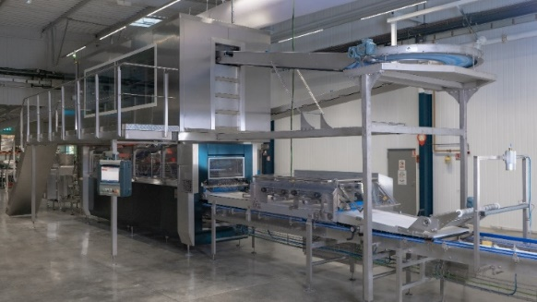 | The new M-RT moulder moulds hydrated dough and guarantees the result of high-quality crusty breads thanks to a movement close to the artisanal method.
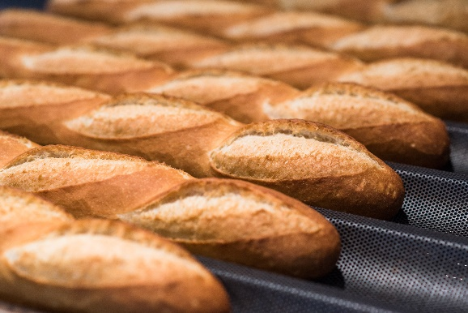 | The result of a hydrated and rested dough, the Authentik Baguette, moulded in the M-RT moulder, offers the advantages of a thin crust as well as a regular and open crumb to meet consumer expectations.
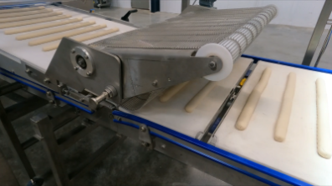 | Depositing of perfectly aligned baguettes on peelboards
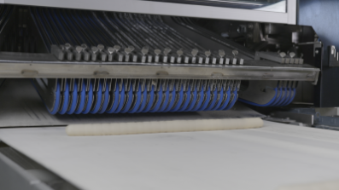 | Final stretching of the product with the cassette stretcher, ensuring the right position of the cut products during depositing.

About MECATHERM

MECATHERM designs, develops, assembles, and installs ovens, machines, and automated lines for bakery, sweet goods, and food making all over the world. These solutions help industrial bakers to meet the challenges of product quality, industrial performance, and sustainability. The company generates more than 90% of its turnover from exports, with customers in more than 70 countries on five continents around the world.
For more information, please visit: www.mecatherm.fr

About TMG
Majority owned by the Unigrains Group, TMG unites its industrial baking equipment and service subsidiaries using a privileged partnership approach. TMG supports the development of each of its brands through shared expertise, processes, and experiences focused on a core set of shared values that include savoir-faire, exemplary performance, and teamwork.

Press contacts

Sophie KERSAUDY, Communication Manager
MECATHERM
Sophie.kersaudy@tmg.biz
Tel +33 6 50 23 73 98

Michaela Demissy and Audrey Puig Sokol
MDS COM
infopresse@mdscom.fr
Tel + 33 1 60 84 53 92 / +33 6 60 89 00 57

